HW2 – Intro to Algorithms  
John Carroll

Exercises 3.2-2 and 3.2-3, Problem 3-1 parts a-c, Exercises 4.2-2 and 4.2-4, Problem 4-1 a-f

**1) Exercise 3.2-2**

**Prove equation (3.16).**

**Ans:** Let’s have logabc = clogab. (Equation *)

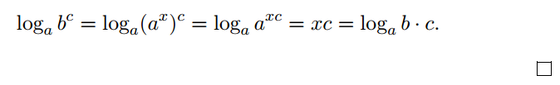**Claim 1:**Let logab= x. Therefore, b = ax. Then,

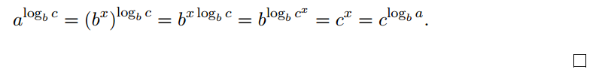**Proof:** Let logba = x. Therefore, a= bx. Then, using Equation *,

**2) Exercise 3.2-3**

**Prove equation (3.19). Also prove that n! = ω(2n) and n! = ο(nn).**

**Ans:**

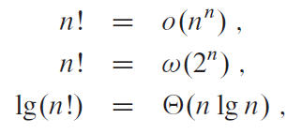

Obviously n! nn, so we know that log n! is Ο(n log n). A lower bound for the factorial function would be found using the following:

Therefore

In other words, log n! is in Ω(n log n). Thus, log n! = Θ(n log n).

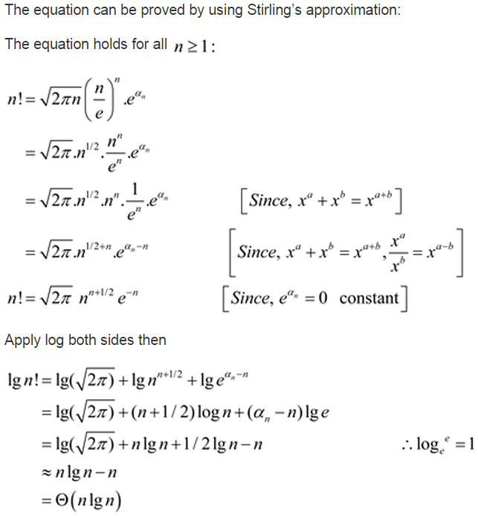

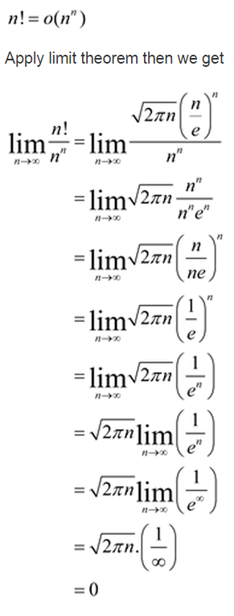

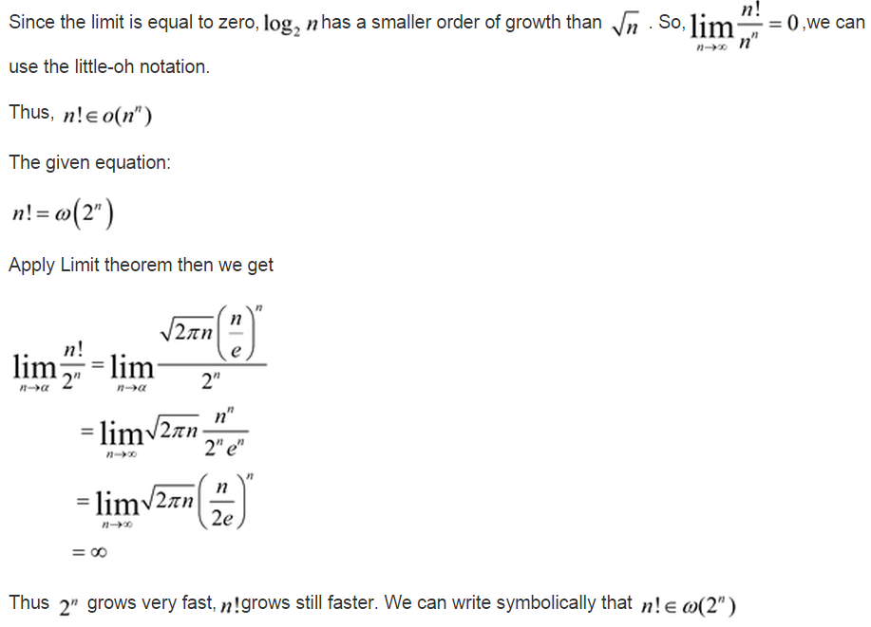

**3) Problem 3-1 a-c**

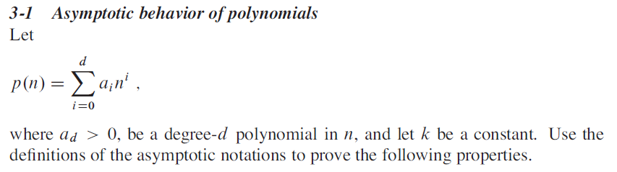

1. **If , then p(n) = Ο(nk).**

**Ans:**

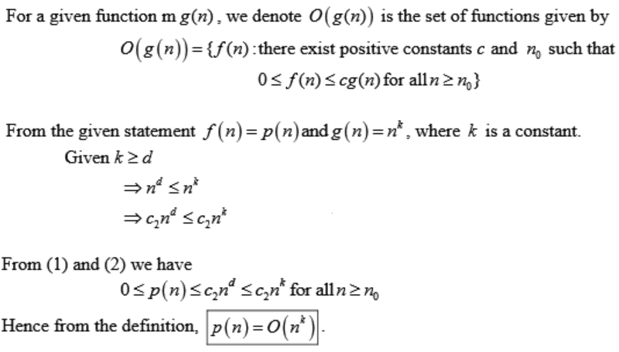

1. **If , then p(n) = Ω(nk).**

**Ans:**

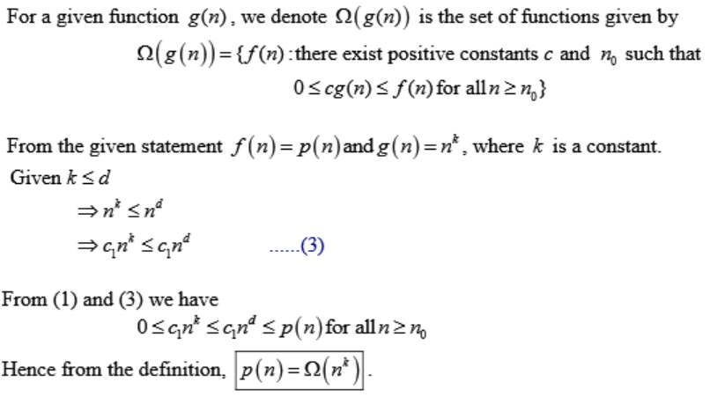

1. **If , then p(n) = Θ(nk).**

**Ans:**

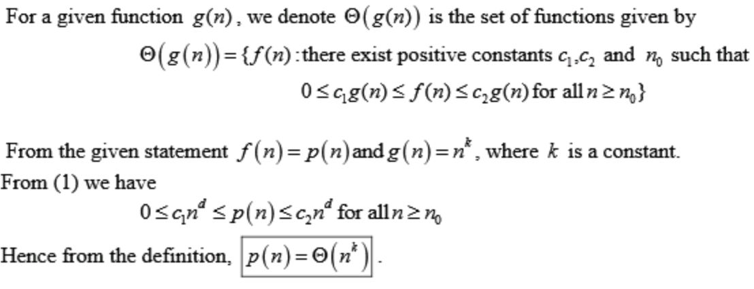

**4) Exercise 4.2-2**

**Write pseudocode for Strassen’s algorithm.**

**Ans:**

def Matrix(a,b):  
 result = []  
  
 for i in range(0,len(a)):  
 new_array = []  
 result.extend(new_array)  
 for j in range(0,len(b[0])):  
 ssum = 0  
 for k in range(0,len(a[0])):  
 ssum += a[i][k] * b[k][j]  
 result[i][j] = ssum  
 return result

**5) Exercise 4.2-4**



**Ans:**

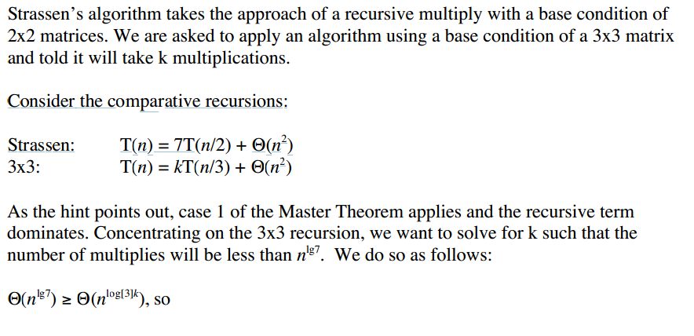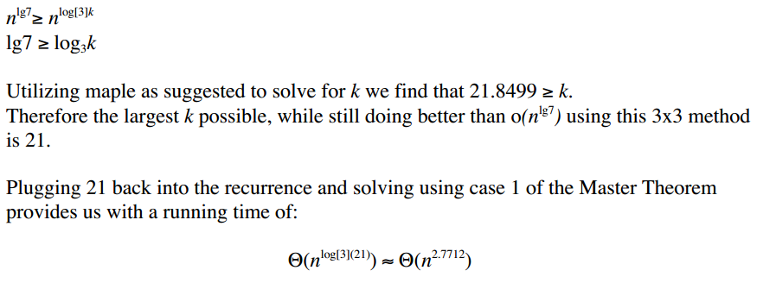

**6) Problem 4-1 a-f**



**Case 3 of the master theorem is applied for parts a, b and d.**

1. 

**Ans:**

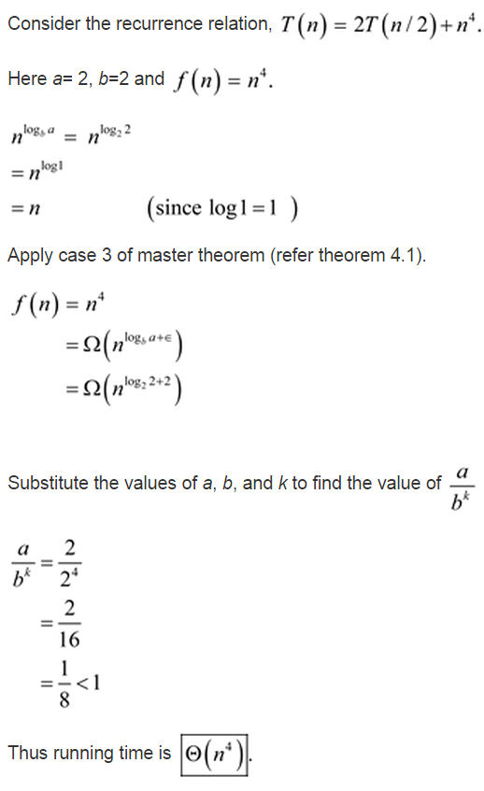

1. 

**Ans:**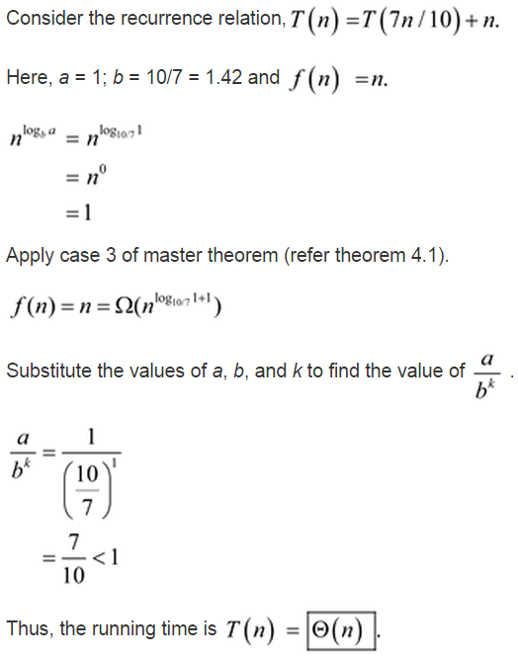

1. 

**Ans:**

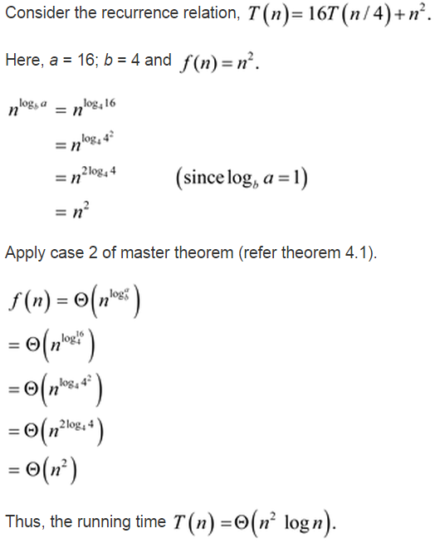

1. 

**Ans:**

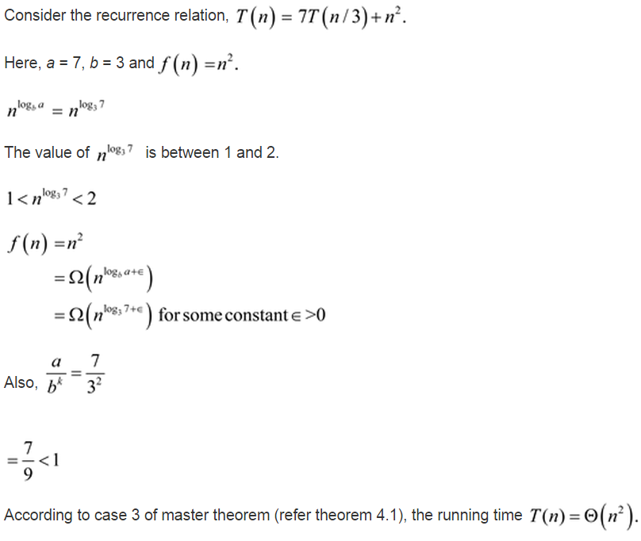

1. 

**Ans:**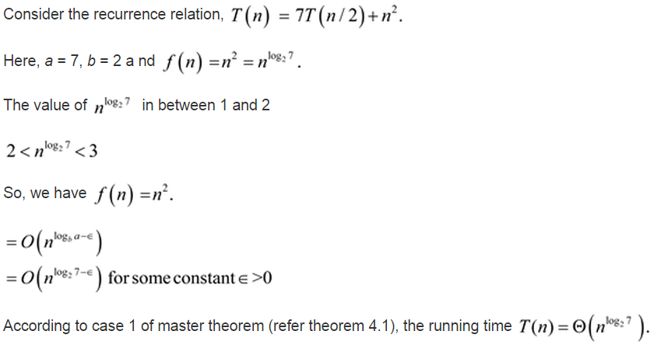

1. 

**Ans:**